**GIT Task 1. Report. Halyna Bila.**

**Part 1. I got started in an empty working directory “GIT Task 1”**

1. I created a repository in this directory and git config with my user name and email address.

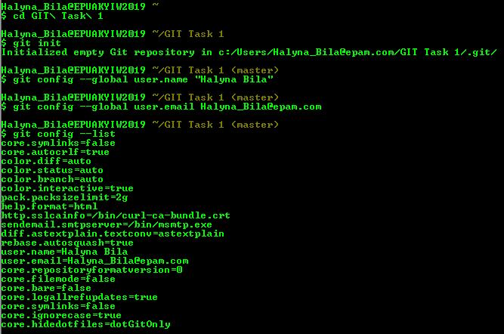

1. I created an empty directory named “student_Bila” and checked if it had been created.

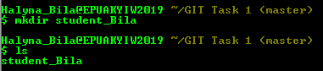

1. Then I created three files in “student_Bila”

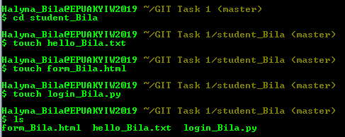

- and checked status of repository.

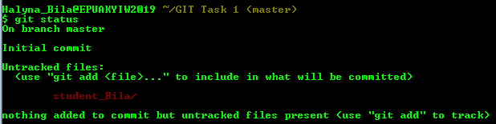

4. I added “student_Bila” to the repository

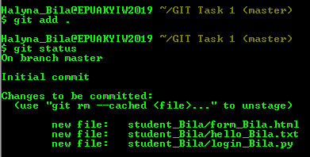

5. And committed changes with comment ‘’first commit Bila”.

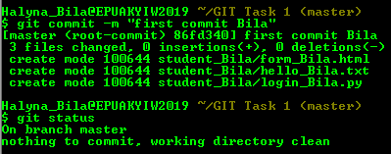

6. I changed the files contents.



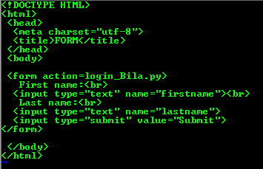









- and committed changes.

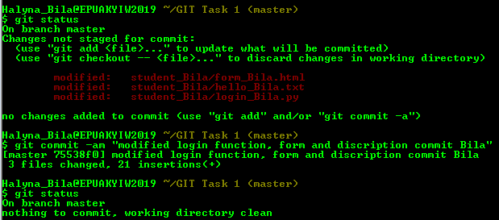

**Part 2. Making changes.**

1. I changed file form_Bila.html and checked status of repository.

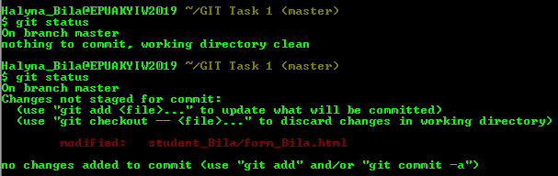

Then I run command git add form_Bila.html to stage changes.

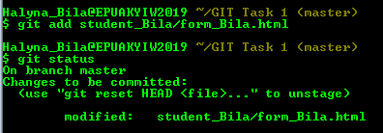

1. I added new changes in form_Bila.html and checked status repository

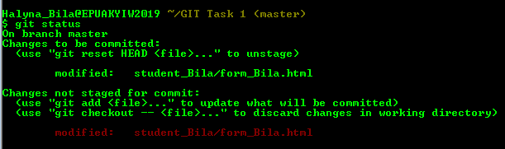

1. Then I committed changes and checked status again

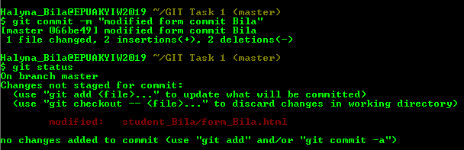

**COMMENT:** A second change of file form_Bila.html was not staged, that means git didn’t know about that change in the repository. Before committing, changes should have been added to stage.

1. Then I got the project’s history by showing a list of all commits to the repository using git log command.

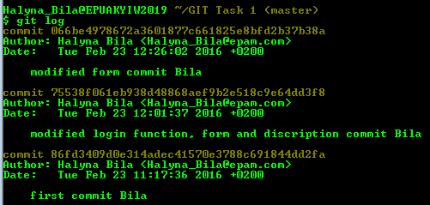

1. To control the display of entries and show the commits in 5 last minutes I used the following parameters

C:\Users\Halyna_Bila@epam.com\Capture.PNG

**Part 3. Going back in history.**

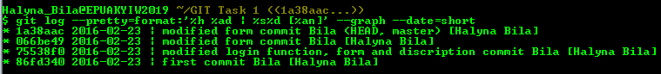

1. I went back to the second commit by the appropriate hash value.

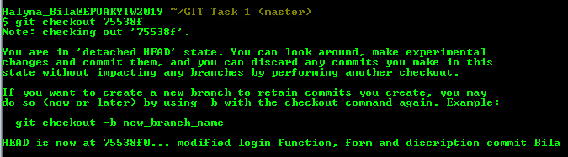

1. Then I returned back to the last commit.

C:\Users\Halyna_Bila@epam.com\Capture.PNG

**Part 4. Creating a tag.**

1. I created a tag V1_Bila in the current snapshot of repository,

C:\Users\Halyna_Bila@epam.com\Capture.PNG

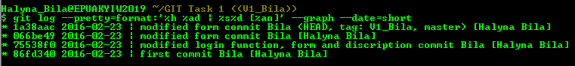

1. Added two commits,

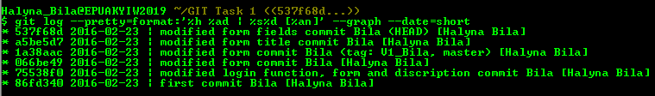

1. And checked out between the current version and tag version V1_Bila.

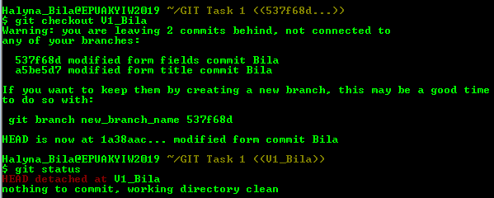

1. Then I returned back to the master.

C:\Users\Halyna_Bila@epam.com\Capture.PNG

**Part 5. Function ‘revert’.**

1. I made changes to the form_Bila.html file and checked status.

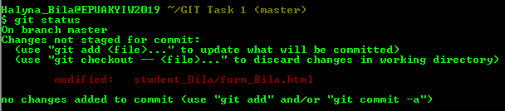

1. I staged the modified file.

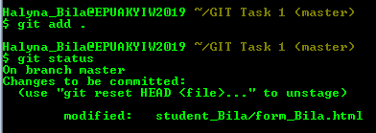

1. **COMMENT**: the displayed status showed exactly what I should have done to cancel staged changes. The ‘revert’ command does not reset the buffer zone to HEAD before committing. As a result, revert failed. In such cases the ‘reset’ command should be used.

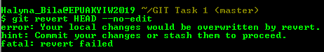

1. I made changes to the form_Bila.html file and checked status again.

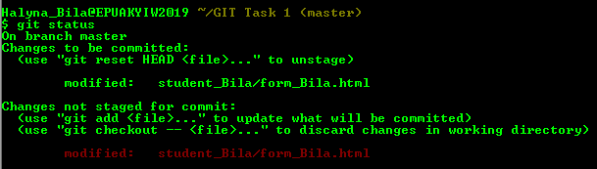

1. I staged the modified file and committed changes.

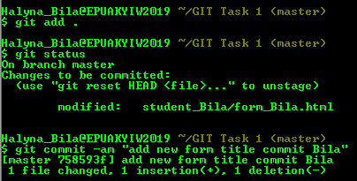

1. I run ‘revert’ command to revert the last commit.

C:\Users\Halyna_Bila@epam.com\Capture.PNG

1. The history of project’s changes was next:

